**22AIE303 DBMS**

**LABSHEET 2**

Date:23/9/2024

**Abhiram A S**

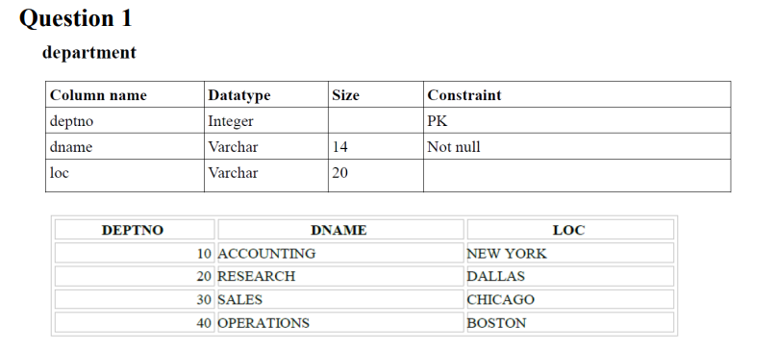



**CREATE TABLE department(**

**deptno INT PRIMARY KEY,**

**dname VARCHAR(14) NOT NULL,**

**loc VARCHAR (20)**

**);**



**INSERT INTO department VALUES**

**(10 , 'ACCOUNTING' , 'NEW YORK'),**

**(20 , 'RESEARCH' , 'DALLAS'),**

**(30 , 'SALES' , 'CHICAGO'),**

**(40 , 'OPERATIONS' , 'BOSTON');**

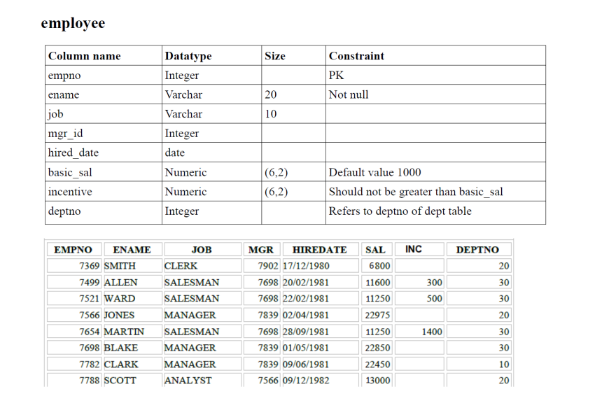



**CREATE TABLE employee(**

**empno INT PRIMARY KEY,**

**ename VARCHAR(20) NOT NULL,**

**job VARCHAR(10),**

**mgr_id INT,**

**hired_date DATE,**

**basic_sal NUMERIC(6,2) DEFAULT 1000,**

**incentive NUMERIC(6,2),**

**deptno INT,**

**CONSTRAINT incentive_check CHECK(incentive <= basic_sal),**

**FOREIGN KEY (deptno) REFERENCES department(deptno)**

**);**



**INSERT INTO employee VALUES**

**(7499,'ALLEN','SALESMAN',7698,'20/02/1981',11600,300,30),**

**(7521,'WARD','SALESMAN',7698,'22/02/1981',11250,500,30),**

**(7654,'MARTIN','SALESMAN',7698,'28/09/1981',11250,1400,30)**

**;**

**INSERT INTO employee**

**(empno,ename,job,mgr_id,hired_date,basic_sal,deptno)**

**VALUES**

**(7369,'SMTIH','CLERK',7902,'17/12/1980',6800,20),**

**(7566,'JONES','MANAGER',7839,'02/04/1981',22975,20),**

**(7698,'BLAKE','MANAGER',7839,'01/05/1981',22850,30),**

**(7782,'CLARK','MANAGER',7839,'09/06/1981',22450,10),**

**(7788,'SCOTT','ANALYST',7566,'09/12/1982',13000,20)**

**;**



**SELECT * FROM department;**



**SELECT * FROM employee;**



**SELECT * FROM employee WHERE ename = 'BLAKE';**



**SELECT empno,ename FROM employee WHERE job = 'MANAGER';**



**SELECT DISTINCT(job) FROM employee WHERE job LIKE '_A%';**



**SELECT ename||job FROM employee;**



**SELECT ename,deptno,hired_date from employee;**



**SELECT * FROM employee ORDER BY ename;**



**SELECT ename FROM employee WHERE ename LIKE 'S%' OR ename LIKE 'J%';**



**SELECT max(basic_sal) from employee;**



**SELECT ename,deptno FROM employee WHERE basic_sal BETWEEN 10000 and 25000;**



**SELECT deptno,COUNT(empno) FROM employee GROUP BY deptno;**



**SELECT ename,hired_date FROM employee**

**WHERE (job IN ('MANAGER','CLERK')) AND incentive IS NULL;**



**DELETE FROM employee WHERE deptno = 10**



**SELECT ename,job FROM employee WHERE job <> 'ANALYST';**



**SELECT ename FROM employee WHERE basic_sal > 21000;**



**SELECT ename from employee WHERE basic_sal = 13000;**



**SELECT ename, deptno, hired_date from employee WHERE deptno IN (20,30);**

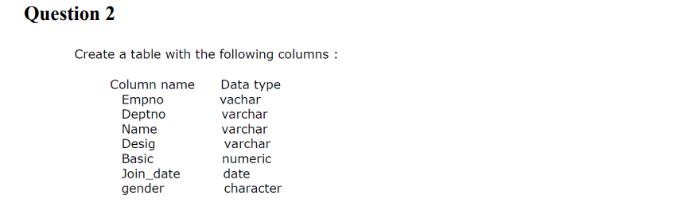



**ALTER TABLE employees**

**ADD CONSTRAINT prime PRIMARY KEY(empno,deptno);**



**INSERT INTO employees VALUES**

**(22001,'D1','THARUN','MANAGER',80000,'12-07-2023','M'),**

**(22002,'D2','ABHIRAM','ANALYST',75000,'27-04-2024','M'),**

**(22003,'D3','ADITHYA','CONSULTANT',78000,'16-10-2022','M');**



**SELECT * FROM employees;**



**SELECT empno,emp_name,desig,basic_sal FROM employees;**



**SELECT empno,emp_name FROM employees WHERE deptno = 'D2';**



**SELECT empno,emp_name,desig,deptno,basic_sal FROM employee**

**ORDER BY basic_sal;**



**SELECT DISTINCT(desig) from employees;**



**SELECT empno,emp_name,desig,basic_sal from employees**

**ORDER BY basic_sal DESC, emp_name;**



**SELECT * FROM employees ORDER BY basic_sal;**



**DELETE FROM employees WHERE basic_sal < 5000;**

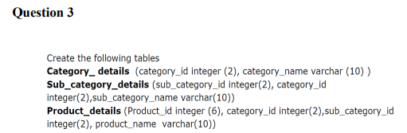

**CREATE TABLE category_details(**

**category_id INT(2),**

**category_name VARCHAR(10),**

**);**

**CREATE TABLE category_details(**

**category_id INT,**

**category_name VARCHAR(10),**

**);**

**CREATE TABLE sub_category_details(**

**sub_category_id INT,**

**category_id INT,**

**sub_category_name VARCHAR(10)**

**);**



**ALTER TABLE category_details**

**ADD PRIMARY KEY(category_id);**



**ALTER TABLE sub_category_details**

**ADD CONSTRAINT category_prime PRIMARY KEY(sub_category_id);**



**ALTER TABLE sub_category_details**

**ADD CONSTRAINT fk_category FOREIGN KEY (category_id) REFERENCES category_details (category_id);**



**ALTER TABLE product_details**

**ADD PRIMARY KEY (product_id),**

**ADD CONSTRAINT fk_category_id FOREIGN KEY (category_id) REFERENCES category_details (category_id),**

**ADD CONSTRAINT fk_sub_category_id FOREIGN KEY (sub_category_id) REFERENCES sub_category_details (sub_category_id);**



**ALTER TABLE product_details**

**ADD COLUMN price NUMERIC(6,2);**



**INSERT INTO category_details (category_id, category_name) VALUES (1, 'Electronics'), (2, 'Clothing');**

**INSERT INTO sub_category_details (sub_category_id, category_id, sub_category_name) VALUES (1, 1, 'Mobiles'), (2, 2, 'Dresses');**

**INSERT INTO product_details (product_id, category_id, sub_category_id, product_name, price) VALUES**

**(101, 1, 1, 'iPhone', 999.99),**

**(102, 1, 1, 'Android', 599.99),**

**(201, 2, 2, 'Skirt', 49.99),**

**(202, 2, 2, 'Jeans', 89.99);**



**ALTER TABLE product_details**

**ADD COLUMN BRANDNAME VARCHAR(20) NOT NULL;**



**ALTER TABLE category_details**

**RENAME TO Cat_dt;**